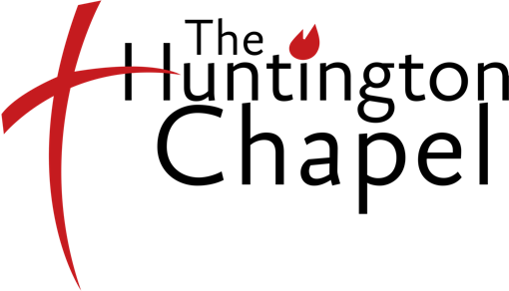
Huntington Chapel Sunday School/Nursery
2021-2022 Registration Form

** Please List all children attending ages 3-5th grade in one family

Children’s Information
Child’s First and Last Name Grade Birthday Age
1:
2:
3:
4:
5:
6:
7:
8:

Parents’ Information
Parent/Guardian Name: Cell #:
Email: Home #:
Address:
Town: State: Zip-code:

Parent/Guardian Name: Cell #:
Email: Home #:
Address:
Town: State: Zip-code:

Emergency Contact (if other): Name:
Email: Cell:

Please specify any medical, allergies (food allergies), or educational needs (along with name of child):

Service Opportunities
I would like to serve in my child’s Sunday School class. Please call me to schedule dates.
Helper Substitute-Teacher
Snack Provider Other

My consent is given to the Huntington Chapel staff and volunteers to treat my kids medically as needed

Parent/Guardian: (Print) Parent/Guardian (Signature) Date

Note: Your signature gives consent for release of photos/videos for God honoring promotional purposes online and in print

