Cleaning Supplies R Depot

Tissue Boxes
Toilet Paper
Softpull Paper Towels-order Amazon
Paper Towels
Large Garbage Bags
Small Garbage Bags
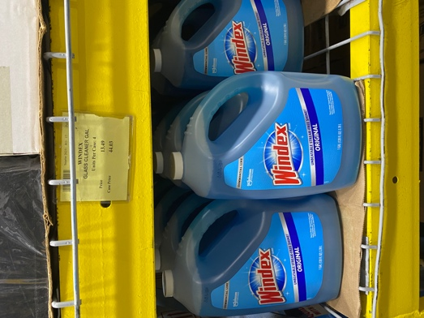
Handsoap
Dishsoap
Bleach 1 gallon
Bleach spray (Clorox)
Latex Gloves
Swiffer Wet cloth
Windex
Windex refill Only Windex refill ($13.49)
Air Freshener
Stainless Steel sink cleaner
Other:

